Participation workshop, September 2014
More than seventy people attended this workshop, at the Alberta Museums Association annual conference in Calgary, in September 2014. Their challenge was two-fold:
- To make proposals that would help to create a user-friendly environment and thus make it more likely that people would participate in museum activities.
- To put forward simple approaches that would stimulate user participation. We recognised that deeper engagement would require a different level of exhibit. The ambition here was to take the first steps to creating an environment in which users would expect to take part.

Creating a user-friendly museum environment
Creating a friendly museum environment will enable our museums to broaden the range of audiences who come and will make it more likely that our visitors will enthusiastically participate in museum activities. The creation of a friendly environment requires a shared vision that places visitors at the heart of the museum. We must put the visitor first, looking at every stage of the visitor experience from pre- to post-visit, and ensure every member of the museum team plays a visitor-centred role:
If everyone in the museum – and I mean everyone from cleaner to director – believes that their first and most important duty is to ensure that each and every visitor gets what they want from their visit then the museum will be [visitor] friendly. It’s as simple and as hard as that. It’s not primarily about the nuts and bolts, and the ticking of check lists. It’s about attitude. Get that right and you’re a winner.
Ian Forbes, Director, Killhope North of England Lead Mining Museum, winner of the first Guardian Family Friendly Award, 2004
http://www.kidsinmuseums.org.uk/the-guardian-award/2004-guardian-family-friendly-museum-award/

To plan, create and sustain a friendly environment, we must look at every aspect of the experience, from first contact with the museum to the resources that can be drawn on after the visit. The workshop focused on three elements:
- Creating a welcoming environment
- The creative use of seating (also highly relevant to simple participative exhibits)
- Ensuring ‘good goodbyes’

1. Welcoming environment

Ensuring the crucial positive first impressions

… the single most significant barrier to inclusion is the visitor feeling unwelcome and being embarrassed because they do not know where to go or what to expect.
Stewart-Young, J. (2000) Building Barriers in Walsall, Museums Journal, June 2000, p30.

Pre-visit
- Have pre-visit conversations
- Ensure website and other digital presence (Twitter, facebook) is inviting and up-to-date
- Use website etc. to create expectations in advance of the visit

Environment
- Warm colours – use decoration & not just white walls
- Good, warm, creative lighting – not a dark hole
- Use of appropriate music
- Create ‘unsilence’ – people in costumes, music, not being stagnant
- Fresh air, open windows
- Smells that stick with the visitor
- Keep the museum tidy
- Create an authentic experience – don’t have a ‘canned’ space, have the experience create a compelling atmosphere

Support
- Warm, welcoming staff - personal contact – host person to welcome visitors
- Ask visitors how they heard about the museum, what brought them back
- Handicap accessible – barrier free
- Avoid ‘do not’ negative signage
- Good orientation – pamphlets to carry, way-finding signage
- Careful how you word signage about tours – make inviting
- Make the environment receptive to what the exhibit is covering
- Create an experience right away – a ‘hook’
- A thought-provoking way to engage you in the exhibit
- Invite visitors to take photos
- Invite visitors to touch - have a symbol pointing out what can be touched
- Keep displays up to date
- Unobtrusive security, or have them excited about the exhibition and able to answer questions
- Someplace for visitors to talk
- Separating the physical distance between people can lead to conversations

2. Creative use of seating

Basics
- Large sites need lots of seating (picnic areas indoor and outdoor, kitchen tables, benches in church, school desk seat in schoolroom). Comfortable!
- Accessible seating that thinks of everybody – different abilities/disabilities
- Outdoor seating area for programming (to be messy)
- Indoor and outdoor seating to enjoy the space/experience the environment/be part of the exhibit
- Arrange seating at different heights in relation to exhibit – e.g. low as child level
- Seating for children in a children’s museum – comfortable & moving
- Strollers (seating for kids)
- Walkers to help stay standing too
- Clean floor!
- Markers given to visitors to share with museum where they want to sit/how they want to experience the space
- Pile of cushions/portable seating/organic seating arrangement/casual seating area for individuals and groups (freedom visitors to choose where and how they want to sit)

Museum specific
Create opportunities for visitors to sit on ‘props’ (based on artefacts/exhibits), e.g. sit on/in tank if army museum; fire truck if firefighter museum
Incorporate seating into exhibit/themes – like river theme at Fort Sask library, or a tent with seating in
Area to sit for photo opportunity – selfie
Experience different seating/experiential (e.g. dentist’s chair, throne, tepee)
Use seating to encourage people to watch multimedia exhibits
Activity – build your own seating. Seating as the product/by-product of a hands-on activity

Creative
- Art stations inside exhibit space (encourage creativity)
- Seats to do things and play (e.g. sewing, weaving, playing instruments)
- Book nook (couches arranged for reading material; creating space to read, storytime)
- Use seating to socialise visitors with each other/start conversation – not a lonely experience, e.g.
- Circular table (encourages conversation)
- Kitchen table seating (again to encourage conversation)
- Hidden seating - Murphy bed type area

3. Good goodbyes
- with thanks to Shannon Quigley for editing the notes

- Give aways
- Token/takeaway – pin, button, postcard
- Completed craft to take home

- Good buy$ - exit through gift shop
- Unique and relevant souvenirs – include unique local products, works by local artisans (with affordable options)

- Guestbook/photobooth – leave feedback
- Have a sign-up sheet for E-news and use it to send a ‘personalised’ message thanking them for their visit to the site. Could ask them if they had fun and invite other feedback.
- Feedback/photo booth to record/comment on experience at museum – but do not pressurise (no one likes the words survey/feedback – ‘opinion’ might be a better term to use)
- If you collect feedback, tell visitors what it is going towards –let them know that it makes a difference
- Post comments on tree or leave a message in a bottle – create a ‘guestbook’ that is visually striking, fun to do, and fun for other visitors to look through
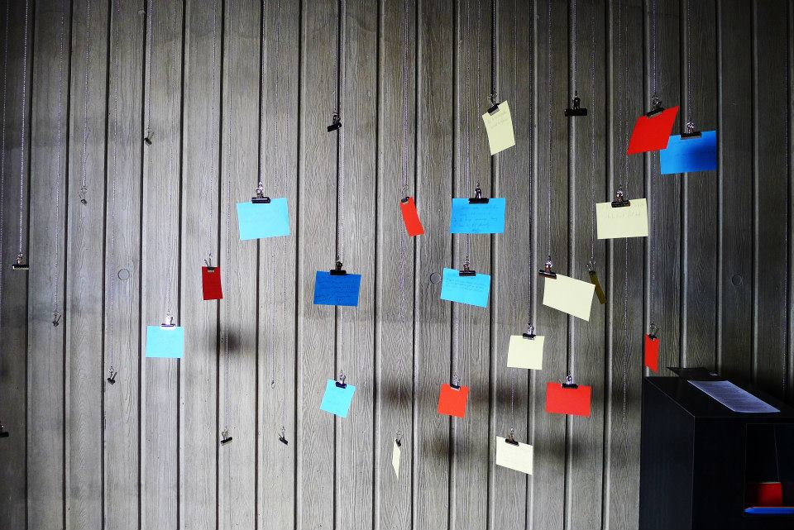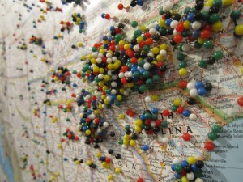

- Leave with a project/contest follow-up
- Give a take-home activity or challenge – innovatory, related to exhibits
- Give a plant seed and ask to take photo of growing plant and send to museum. Have a mini produce fair – do the activity at a famer’s market
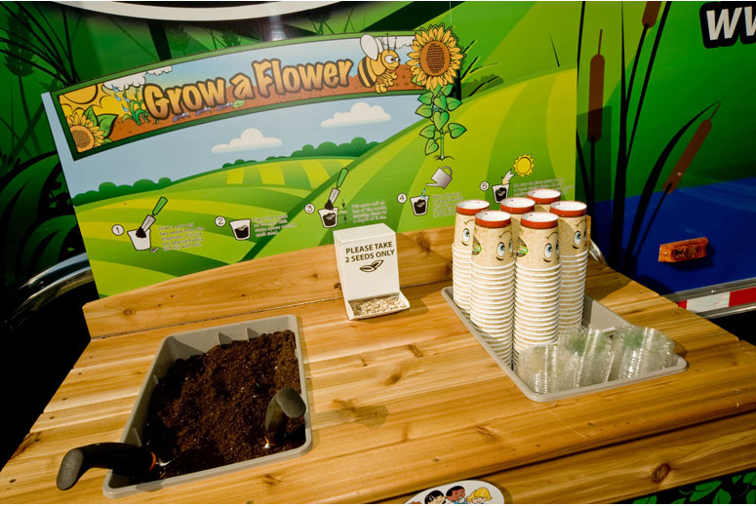
- Have a contest/exchange based on take-home. Send in a picture of the completed craft or challenge and give a prize to the winner. Put a picture of them or their project on a wall of fame:
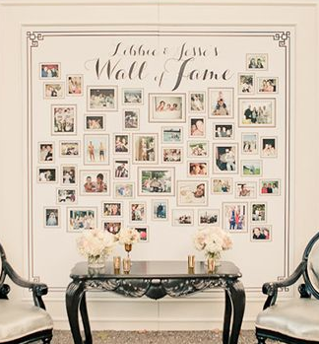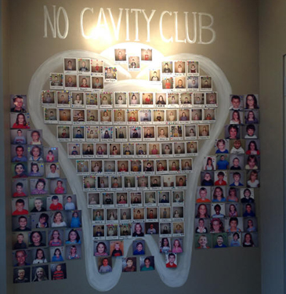

- Food/café – cheap and tasty
- Café – cheap/tasty – PIE! Have good food/drink – somewhere that is good to eat/chat/linger

- PASSPORT/TIME CARD – stamp per visit, per site
- Titanic exhibit and other similar – given replica ticket with a name when you entered and at end discovered whether that person survived or not – you keep the ticket
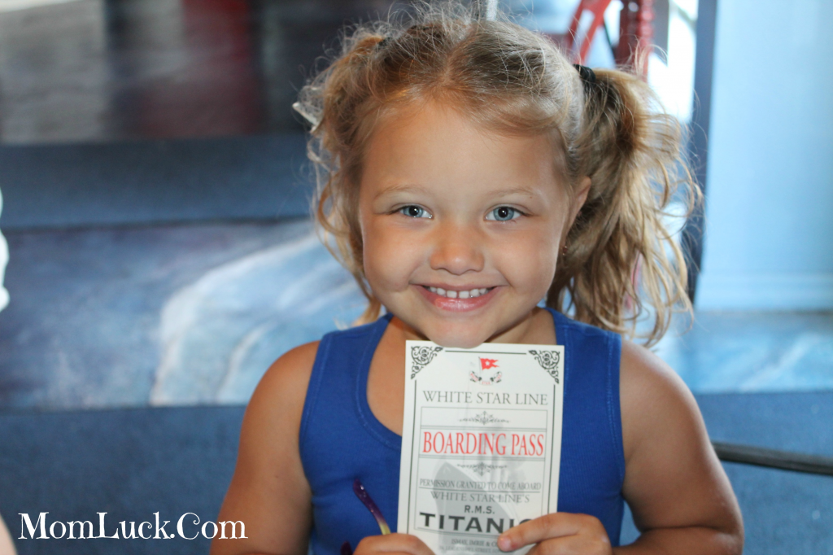
- PASSPORT – stamp for each activity/exhibit – get something when filled up. Could partner with other museums.
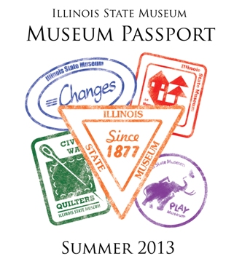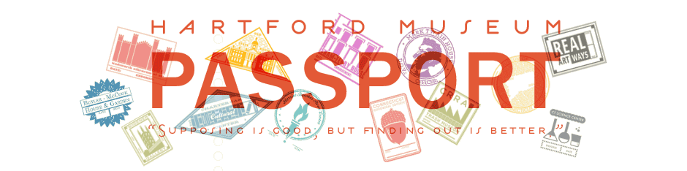
- TIME PUNCH your ticket – especially if the exhibit/museum relates to the industrial revolution, factories, work etc.
- Award ‘Gallery Bucks’ for participating in events (no monetary value). These can be used to unlock different levels of games or other content on future visits. Visitors will (hopefully) return to the gallery or attend the next event to redeem their Gallery Bucks.

- FUN EXIT –leave on a high
- E.g. go down a fire pole or slide
- Is there an exit/entrance linked to the exhibit theme? Spaceship escape pod, wardrobe into Narnia, curtain/stage door, vortex
- 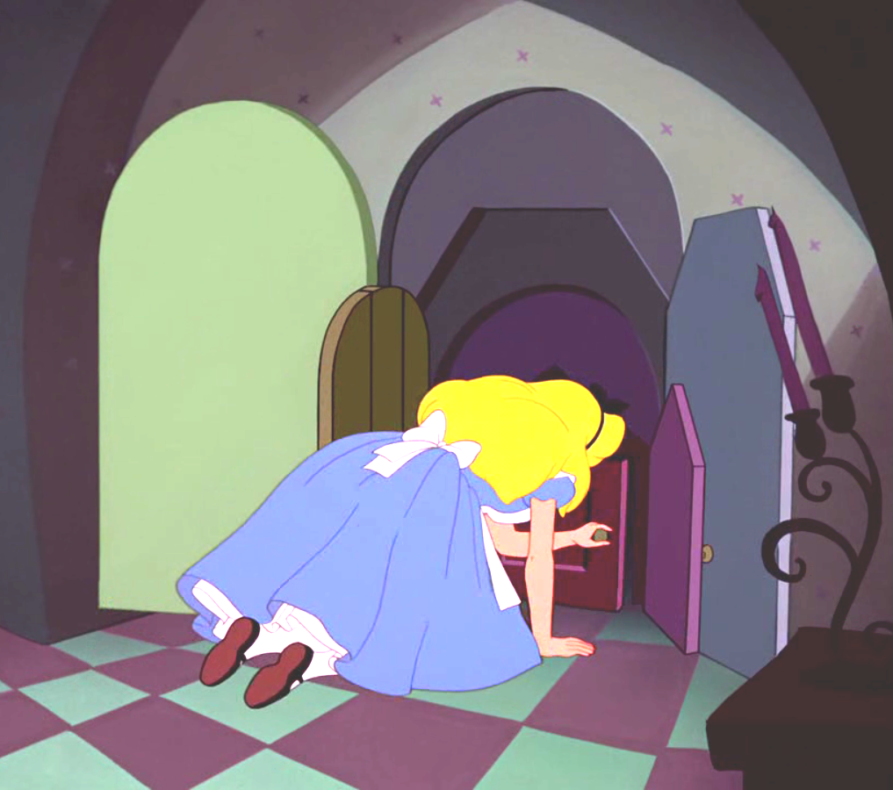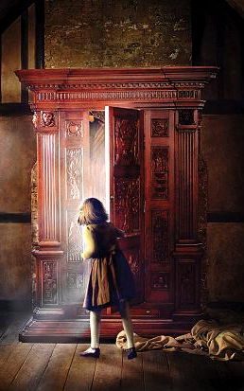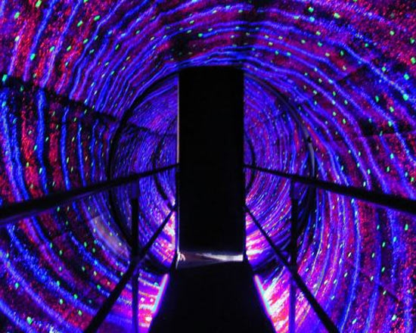

- Friendly face
- Ask them what they are looking for/why they are visiting when they arrive. Ask them whether they found it (specifically) when they leave
- Staff/volunteer to say goodbye/thankyou/please come again – ask ‘how do you say goodbye where you are from?’

- Other
- Highway sign – hello/goodbye, thanks for visiting
- Photo opportunity
- Mailbox and postcards - mail something to yourself or a friend

Stimulating user participation

The second challenge for the workshop was to propose the strategic use of minor changes that begin the process of transforming ‘permanent’ exhibitions. Yes, the long term ambition is for a profoundly different, more participatory, more meaningful museum experience – and one where there is always something new happening. The proposals here represent the first step, in themselves enhance the visitor experience and also buy time while your museum plans more profound change.

Again, three headings were used, with some overlap between them:

- Developing cheap participative exhibits
- Stimulating conversations around objects
- Stimulating user contributions

4. Cheap participative exhibits

Cheap
- Toys and games
- Hands-on/handling collection
- Self portraits
- Sketchers
- Scavenger hunts
- Where’s Waldo/ amazing race

Pretty straightforward
- “Favourite object” exhibits
- “Art Days” at the museum
- “Bring your own” exhibit days
- “Green hands” exhibits (kids)
- Message boards/communication board
- Maker station/maker labs
- Geocaching
- Instagram

More complex
- “Tech in your pocket”
- Capture user-generated content
- Personal stories shared/recorded
- Photo booth/movie booth
- Music videos/movie booth
- Participatory art (smartphone ‘sculpture’)
- “Antiques Road Show”
- Video challenges

Serious long term comitment
- Community curating

5. Stimulating conversations around objects

Start ups
- Competitions – do you know what this object is? – use social media, and/or link to local newspaper
- Photo albums – ask public to tell you who is in the picture
- Riddles
- ‘Conversation point objects’ – on table with chairs around
- Craft objects – recreate crafts/games
- Compare then and now, e.g. typewriters
- Handling collection – dress up, music, games – using the object how it would have been used originally
- Encourage people to take pictures of themselves with objects
- Digital conversations: use facebook/twitter for image of the week

Working with museum visitors and regulars
- ‘Show and tell’ – ask visitors to bring an object
- Pop-up museums’
- Museum of Lost Love
- Use museum expertise to facilitate story-telling – help visitors tell their stories/feel they ‘belong’ in the museum
- Young curator programme
- Using objects to discuss current social/community issues – objects from collection that reflect the issue

6. Stimulate user contributions

Start-up level
Encourage photographs/selfies to be taken in museum and sent into the museum for use/display
Encourage tweets about exhibits by projecting them immediately in that same gallery space
Create a contest that people can vote on – hands-on or online polls re artifacts, etc.
Visible voting on topics – e.g. vote by putting your ping pong ball in a tube, where everyone can see them adding up
Use themes that many people share – e.g. ask community ‘the best thing I ever got for Christmas was...’
Do “then” and “now” photographs of same location
Use archival photographs to do a scavenger hunt

Greater complexity
Activity that brings together people who have a shared experience – e.g. High Riven: collect river rocks and paint them at 1 year anniversary of the 2013 flood
Partnering with local groups (e.g. school children ) to share their work/stories: co-curate
Off-site displays and activities, e.g. being involved in local events
Encourage visitors to bring in their own artifacts
Have visitors role play/participate in historical recreations
Pose open-ended provocative questions – provide sticky notes for visitors to provide answers/comments

The ultimate ambition
Present controversial issues – pose the issues and let people choose their pathway then discuss alternatives and where they sit

Process
Tactile experiences with handling collections – e.g. record your comment using an historic typewriter
Give people respectable/respectful tools to provide their feedback with (e.g. full pencil, not small golf pencil)
Provide a topic with tools for people to record/share their experiences around that topic and display them
Provide adequate instruction when needed but make it easy and casual to participate

